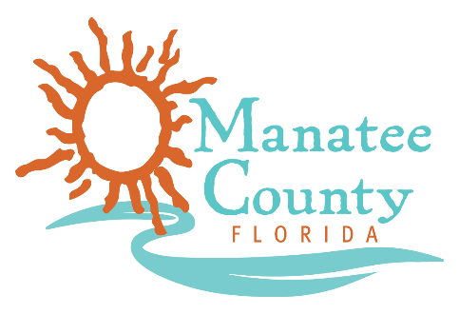

Notice of Award

Notice is hereby given that Manatee County Government (County) awarded contracts on October 11, 2018 and October 22, 2018 for the Electrical Services, Solicitation No. 18-R068118BLS as follows:

Contract title: Electrical Services
Awarded company: Soltech Energy LLC dba Soltec Electric
Contract term: October 11, 2018 through October 10, 2021 w/2-1 year renewals
Contract amount: $100,000 estimated annually

Contract title: Electrical Services
Awarded company: MCS of Tampa, Inc.
Contract term: October 22, 2018 through October 21, 2021 w/2-1 year renewals
Contract amount: $100,000 estimated annually

Contact the Procurement Representative for additional information:
Name: Bonnie Sietman
Phone: (941) 749-3046
Email: bonnie.sietman@mymanatee.org

