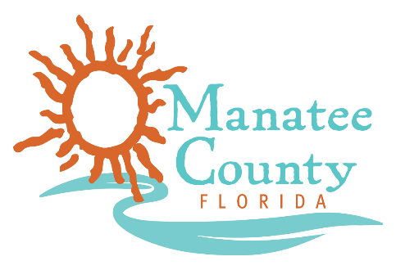

Notice of Award

Notice is hereby given that Manatee County Government (County) awarded a contract on December 10, 2018 for the provision of Rip Rap and Boulder supply, Solicitation No. 19-R069813GE as follows:

Contract title: IFB 19-R069813GE Rip Rap and Boulder Supply
Awarded company: Abbott’s Construction Services, Inc.
Contract term: December 15, 2018 to December 14, 2019
Contract amount: $50,000

Contact the Procurement Representative for additional information:
Name: George Earnest CPPB, Buyer
Phone: (941) 749-3044
Email: George.earnest@mymanatee.org

