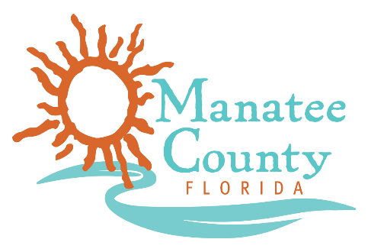

Notice of Award

Notice is hereby given that Manatee County Government (County) awarded a contract on March 19, 2018 for Painting Services, Solicitation No. 18-R067962CB as follows:

Contract title: Painting Services
Awarded companies: Boro Building and Property Maintenance, P.J. Goldman Painting Company, and Hampton Painting
Contract term: March 19, 2018 through March 18, 2021
Contract amount: not to exceed $323,000 annually

Contact the Procurement Representative for additional information:
Name: Charles Bentley
Phone: (941) 749-3036
Email: charles.bentley@mymanatee.org

