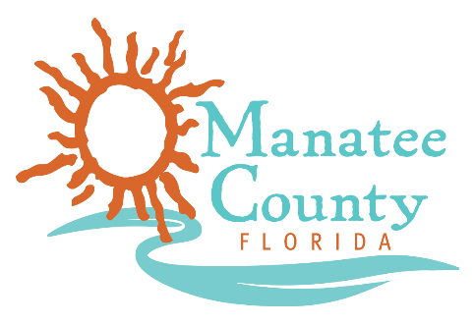

Notice of Award

Notice is hereby given that Manatee County Government (County) awarded a contract on 10/25/2018 for the Marketing Research Services, Solicitation No. 18-R069692MG as follows:

Contract title: Marketing Research Services
Awarded company: Research Data Services, Inc.
Contract term: 5 years
Contract amount: $115,000.00

Contact the Procurement Representative for additional information:
Name: Maria Goldaraz
Phone: (941) 749-3074
Email: maria.goldaraz@mymanatee.org

