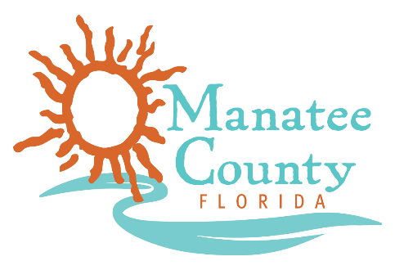

Notice of Award

Notice is hereby given that Manatee County Government (County) awarded a contract on May 21, 2019 for the Manatee County Government Deferred Compensation Plan (the “Plan”), Solicitation No. 18-TA002746AJ as follows:

Contract title: Plan Recordkeeper and Service Provider
Awarded company: Voya Retirement Insurance and Annuity Company
Contract term: July 1, 2019 through June 29, 2024
Contract amount: Employee Contributions to the 457b Plan

Contact the Procurement Representative for additional information:
Name: Abigail Jenkins
Phone: (941) 749-3062
Email: abigail.jenkins@mymanatee.org

