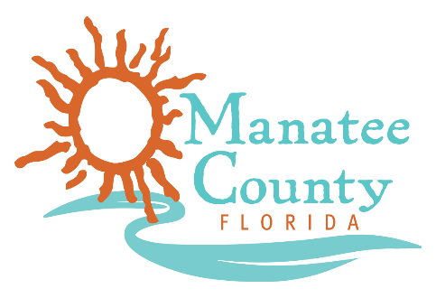

Notice of Award

Notice is hereby given that Manatee County Government (County) awarded a contract on October 23, 2018 for the official 2019 Travel Guide Solicitation No. 18-R068620BLS as follows:

Contract title: Travel Guide
Awarded company: Madden Prepint Media LLC
Contract term: October 22, 2018 through October 21, 2020 w/2-2 yr renewals
Contract amount: $182,000

Contact the Procurement Representative for additional information:
Name: Bonnie Sietman
Phone: (941) 749-3046
Email: bonnie.sietman@mymanatee.org

