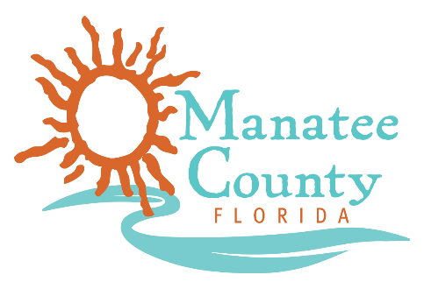

Notice of Award

Notice is hereby given that Manatee County Government (County) awarded a contract on 10/24/2018 for the Microwave Digester System, Solicitation No. 18-R069773MG as follows:

Contract title: Microwave Digester System
Awarded company: CEM Corporation
Contract term: Fixed Price
Contract amount: $29,397.00

Contact the Procurement Representative for additional information:
Name: Maria Goldaraz
Phone: (941) 749-3074
Email: maria.goldaraz@mymanatee.org

