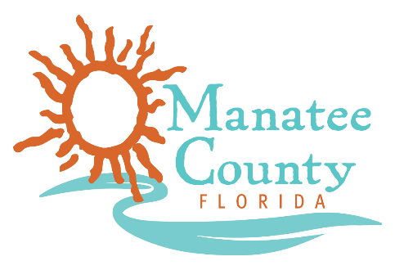

Notice of Award

Notice is hereby given that Manatee County Government (County) awarded a contract on 12/11/2018 for the Disposal of Vegetation Refuse, Solicitation No. 19-R070022MG as follows:

Contract title: Dispose of Vegetation Refuse Service
Awarded company: Consolidated Resource Recovery, Inc.
Contract term: One (1) year with four (4) one-year renewal options
Contract amount: $35.00 per ton

Contact the Procurement Representative for additional information:
Name: Maria Goldaraz
Phone: (941) 749-3074
Email: maria.goldaraz@mymanatee.org

