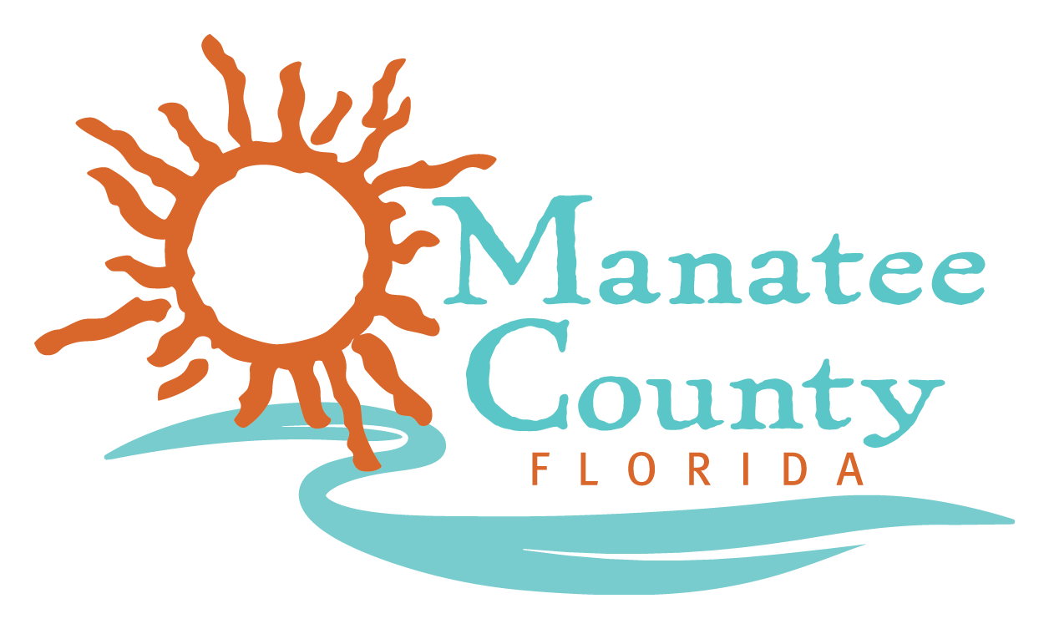

REVISED NOTICE OF PUBLIC MEETINGS
MANATEE COUNTY

The evaluation committee is scheduled to meet at the times, dates and locations listed below to review and evaluate the responses for RFP No.: 18-R069028AJ for Emergency Food Services.

Meeting |  | Start Time | Date | Conference Room
Final Evaluation | Public | 11:00 AM 3:00PM | July 27, 2018 August 2, 2018 | Purchasing

The Purchasing conference room is located at the Manatee County Administration Building, 1112 Manatee Avenue West, Suite 803, Bradenton, FL 34205.

Non-public meetings are not open for attendance by the public.

NOTE: Items that are struck through are deleted. Items that are underlined have been added or changed.

