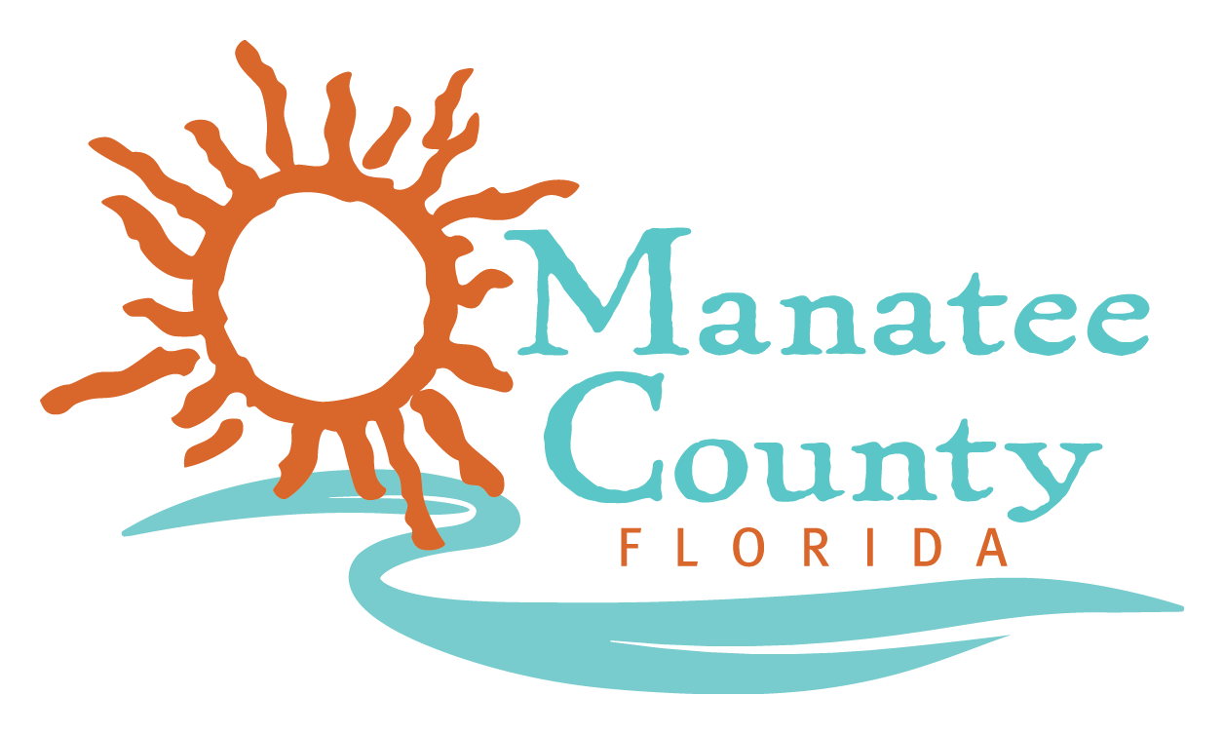

REVISED NOTICE OF PUBLIC MEETINGS
MANATEE COUNTY

The evaluation committee is scheduled to meet at the times, dates and locations listed below to review and evaluate the responses for RFP No.: 18-TA002746AJ for 457(b) Plan Recordkeeper and Service Provider.

Meeting |  | Start Time | Date | Conference Room
Interviews /Presentation | Non-Public | 10:30 AM 9:00 AM | October 18, 2018 | Staples HR Training Conference RM
Final Evaluation Meeting | Public | Conclusion of Interviews  2:30 PM | October 1819, 2018 | Staples Purchasing

The Purchasing and HR Training conference room is located at the Manatee County Administration Building, 1112 Manatee Avenue West, Suite 803, Bradenton, FL 34205.

Non-public meetings are not open for attendance by the public.

NOTE: Items that are struck through are deleted. Items that are underlined have been added or changed.

