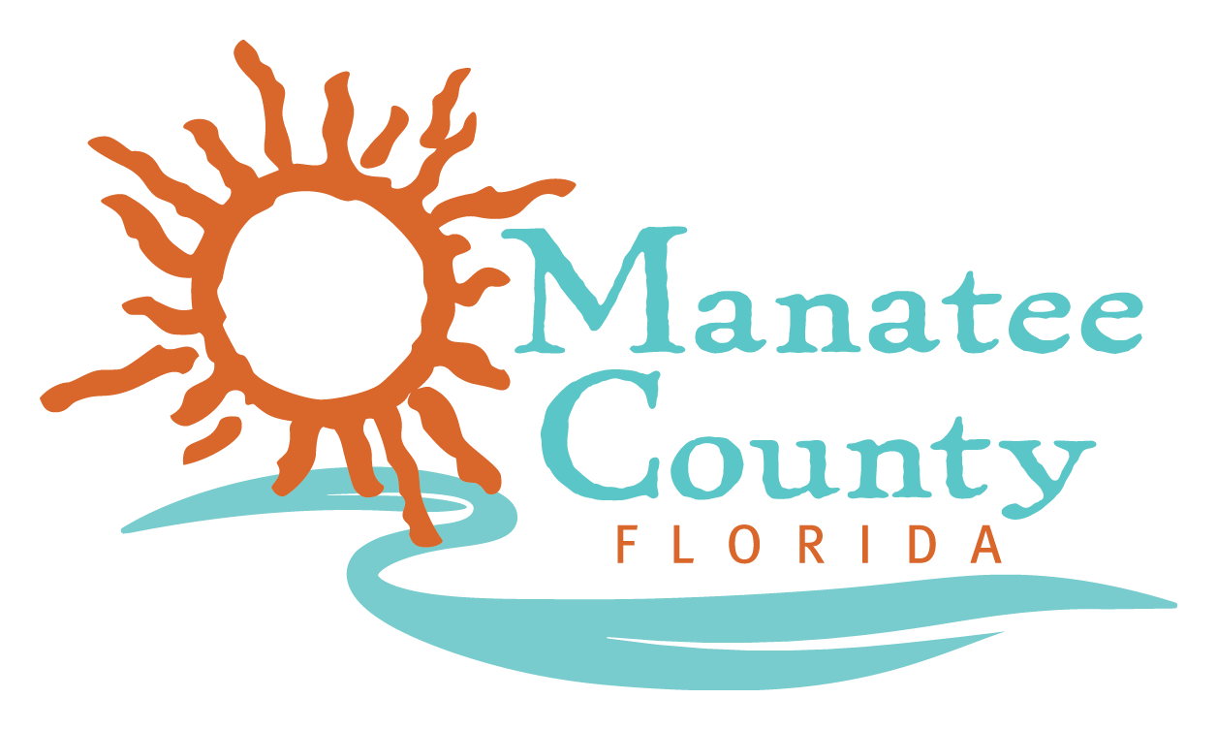

NOTICE OF PUBLIC MEETINGS

MANATEE COUNTY PROCUREMENT DIVISION

RFP No. 20-R074255BLS – Custom Rental Services (for Non-Catered Events)

The Evaluation Committee is scheduled to meet at the times and dates listed below to review and evaluate the proposals received for RFP No. 20-R074255BLS for Custom Rental Services (for Non-Catered Events).

Proposers and/or their representatives may attend the public meetings virtually by accessing the Zoom webinar links below.

Meeting | Type | Date | Start Time | Zoom Webinar Link
Technical Evaluation | Public | November 13, 2020 | 1:00 PM | https://manateecounty.zoom.us/j/88400963721
Second Technical Evaluation | Public | November 17, 2020 | 3:30 PM | https://manateecounty.zoom.us/j/88048037961
Interviews  (if applicable) | Non-Public | November 19, 2020 | 3;30 PM | If applicable
Final Technical Evaluation | Public | November 24, 2020 | 3:00 PM | https://manateecounty.zoom.us/j/86756076335

